INTERNET PROGRAMMING

**Name: Aing Hongsin**

**ID: e20190004**

**Group: I4 GIC A**

Github link: https://github.com/AingHongSin/TP-Internet_Programming-I4

Contents

***Exercise 1: Tab*** 1

**Index.html** 1

**style.css** 2

**script.js** 3

**Result** 5

**Exercise 2: Responsive Menu** 5

**Index.html** 5

**Style.css** 7

**Result** 11

**Exercise 3: Counter** 13

**Index.html** 13

**Styles.css** 14

**Script.js** 15

**Result** 16

**Exercise 4: Random color generator** 16

**Index.html** 16

**Styles.css** 17

**Script.js** 19

**Result** 21

**Exercise 5: Responsive Navigation Bar** 21

**Index.html** 21

**Styles.css** 24

**Result** 27

**Exercise 6: Side Bar** 29

**Index.html** 29

**Styles.css** 34

**Script.js** 36

**Result** 37

# Exercise 1: Tab

## **Index.html**

<!DOCTYPE html>

<html lang="en">

<head>

<meta charset="UTF-8">

<meta http-equiv="X-UA-Compatible" content="IE=edge">

<meta name="viewport" content="width=device-width, initial-scale=1.0">

<title>Tab</title>

<link rel="stylesheet" href="styles.css">

<script src="script.js"></script>

</head>

<body onload="tabClick('History')">

<div class="top">

<h1 class="title">About</h1>

<p class="text">Lorem ipsum dolor sit, amet consectetur adipisicing elit. Animi, unde?</p>

</div>

<div>

<img class="imge" src="https://i.ytimg.com/vi/ndsaoMFz9J4/maxresdefault.jpg" alt="">

</div>

<div class="bottom">

<div class="tab-container">

<div class="tab" id="History" onclick="tabClick(id)" >

<h6 class="title tab-title">History</h6>

</div>

<div class="tab" id="Vision" onclick="tabClick(id)">

<h6 class="title tab-title">Vision</h6>

</div>

<div class="tab" id="Goals" onclick="tabClick(id)">

<h6 class="title tab-title">Goals</h6>

</div>

</div>

<div class="content">

<h6 class="title contex-title" id="context-title">History</h6>

<div id="context-container">

<p class="context text" id="context">

<!-- Lorem, ipsum dolor sit amet consectetur adipisicing elit. Deleniti labore sapiente aliquid eveniet consectetur soluta, autem tempore perspiciatis hic distinctio at eius quibusdam laborum ipsam sint placeat sunt accusantium debitis? Possimus, natus repellat maiores laudantium minus illo atque, nesciunt laborum, quasi iste dicta neque distinctio labore esse architecto soluta pariatur? Dolores ipsam labore dolore dolor ducimus quia, omnis officiis suscipit, rem dignissimos dicta numquam possimus facere quasi incidunt alias. Ratione placeat a nostrum, possimus aspernatur maiores recusandae eum reprehenderit ipsa! -->

</p>

<div class="list-context" id="list-context">

</div>

</div>

</div>

</div>

</body>

</html>

## **style.css**

body {

background-color: #F1F5F8;

text-align: center;

}

.top {

margin-top: 50px;

}

.title {

color: #123959;

font-family: Arial, Helvetica, sans-serif;

}

.text {

color: #8B949B;

font-family: Arial, Helvetica, sans-serif;

}

.imge {

width: 90%;

margin-top: 50px;

border-radius: 10px;

}

.bottom {

width: 90%;

background-color: white;

border-radius: 10px;

margin: auto;

margin-top: 30px;

height: auto;

}

.tab-container {

width: 100%;

height: 50px;

background-color: #DCE2EC;

display: flex;

border-radius: 10px 10px 0px 0px;

}

.tab-title {

font-size: 1rem;

margin-top: 18px;

font-weight: 400;

cursor: pointer;

}

.tab {

background-color: transparent;

flex-grow: 3;

}

.content {

margin-left: 26px;

margin-right: 26px;

text-align: left;

}

.contex-title {

font-size: 16px;

margin-bottom: 10px;

margin-top: 40px;

}

#context-container {

margin-bottom: 20px;

position: relative;

}

.context {

font-size: 16px;

line-height: 1.5rem;

font-weight: 100;

height: auto;

margin-bottom: 40px;

}

.list-context {

/* margin-bottom: 20px; */

font-size: small;

line-height: 5px;

}

## **script.js**

var tabs = document.getElementsByClassName("tab")

var historyTxt = "An essay is a piece of sustained writing in response to a question, topic or issue. Essays are commonly used for assessing and evaluating student progress in history. History essays test a range of skills including historical understanding, interpretation and analysis, planning, research and writing. To write an effective essay, students should examine the question, understand its focus and requirements, acquire information and evidence through research, then construct a clear and well-organised response."

var visionTxt = "As stated above, a vision statement is a very important part of an organization because it aligns with its mission, core values, and culture. It also guides the strategic plan, because it sets future goals. Similar to a mission statement, a vision statement it’s a living document that is referred to as a lodestar to lead a company to its next innovation. There are also different types of vision statements, as companies have unique core values. For example, a motivational vision statement will both motivate existing employees and also drive talent to the company. They’ll want to work at a place with a business vision that aligns with their personal values. A strong vision statement also works to help differentiate your company from others. All companies want to become profitable, but a company can create a unique vision statement that is appealing to its customers and employees."

var goaldTxt = "Make a business for yourself, boy, set some goals. Make a fat diamond out of dusty coals- OUTKAST. Goals are an extremely important thing in life without goals you would just be drifting through life. In ELA my reading goal is to work on my Literary text craft and structure. My writing goal is to improve my vocabulary skills. My personal goal is not one that will be reached soon but it is to become a professional and successful WNBA player. "

function tabClick(id) {

console.log("clicked: " + id);

for (let index = 0; index < tabs.length; index++) {

tabs[index].style.backgroundColor = "transparent";

}

var selectedTab = document.getElementById(id);

selectedTab.style.backgroundColor = "white"

document.getElementById("context-title").innerHTML = id;

var paragraph = document.getElementById("context")

var listContext = document.getElementById("list-context")

listContext.innerHTML = ""

if (id == "History") {

selectedTab.style.borderRadius = "10px 0 0 0"

paragraph.innerHTML = historyTxt;

} else if (id == "Vision") {

paragraph.innerHTML = visionTxt;

listContext.innerHTML = `

<P class="title list-item">list item</P>

<P class="title list-item">list item</P>

<P class="title list-item">list item</P>

`

} else if (id == "Goals") {

selectedTab.style.borderRadius = "0 10px 0 0"

paragraph.innerHTML = goaldTxt;

}

}

## **Result**

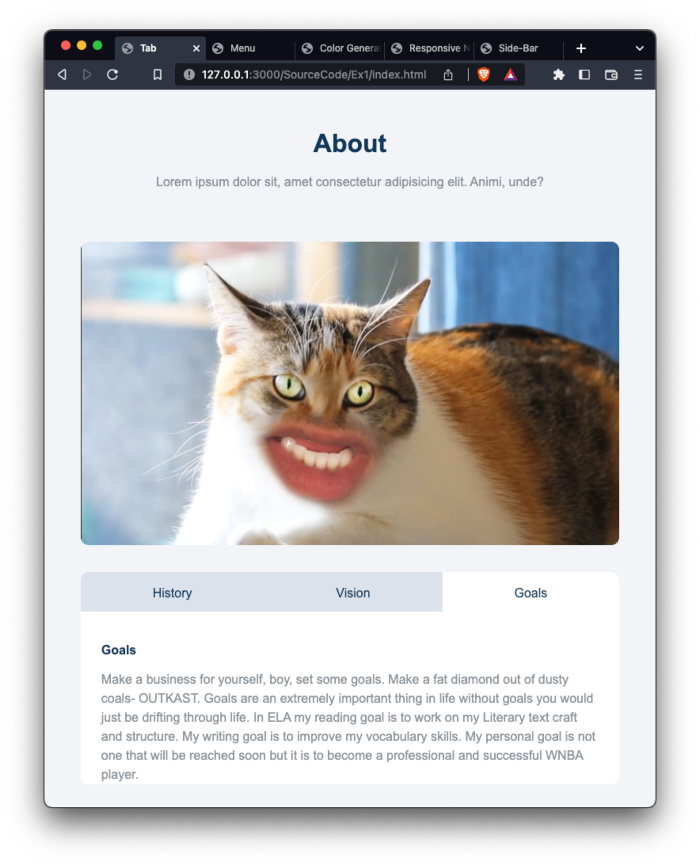

# **Exercise 2: Responsive Menu**

## **Index.html**

<!DOCTYPE html>

<html lang="en">

<head>

<meta charset="UTF-8">

<meta http-equiv="X-UA-Compatible" content="IE=edge">

<meta name="viewport" content="width=device-width, initial-scale=1.0">

<title>Menu</title>

<link rel="stylesheet" href="style.css">

<link rel="preconnect" href="https://fonts.googleapis.com">

<link rel="preconnect" href="https://fonts.googleapis.com">

<link rel="preconnect" href="https://fonts.gstatic.com" crossorigin>

<link href="https://fonts.googleapis.com/css2?family=Roboto:ital,wght@0,100;0,300;0,400;0,500;0,700;0,900;1,100;1,300;1,400;1,500;1,700;1,900&display=swap" rel="stylesheet">

</head>

<body>

<div class="header">

<h1 class="title color1">Our Menu</h1>

<hr class="line color2">

<div class="btn-container">

<button class="cate-btn border-gradient">All</button>

<button class="cate-btn border-gradient">Breafast</button>

<button class="cate-btn border-gradient">Lunch</button>

<button class="cate-btn border-gradient">Shakes</button>

<button class="cate-btn border-gradient">Dinner</button>

</div>

</div>

<div class="content-wrapper" id="content-wrapper">

<div class="content">

<img src="Image/pizza.jpeg" alt="pizza" class="image">

<div class="info">

<div class="titleAndprice-Container">

<h6 class="product-title color1">Pizza</h6>

<h6 class="product-title price color2">$ 15.99</h6>

</div>

<p class="text color1">

Lorem ipsum dolor sit amet consectetur, adipisicing elit. Libero, quaerat!

</p>

</div>

</div>

<div class="content">

<img src="Image/burger.jpeg" alt="" class="image">

<div class="info">

<div class="titleAndprice-Container ">

<h6 class="product-title color1">Hambergur</h6>

<h6 class="product-title price color2">$ 99.99</h6>

</div>

<p class="text color1">

Lorem, ipsum dolor sit amet consectetur adipisicing elit. Nihil nam corrupti ratione iure repellat est accusantium facere quidem sequi ad.

</p>

</div>

</div>

<div class="content">

<img src="Image/spagetti.jpeg" alt="" class="image">

<div class="info">

<div class="titleAndprice-Container">

<h6 class="product-title color1">Spagetti</h6>

<h6 class="product-title price color2">$ 15.99</h6>

</div>

<p class="text color1" >

Lorem ipsum dolor sit amet consectetur, adipisicing elit. Libero, quaerat!

</p>

</div>

</div>

<div class="content">

<img src="Image/milktea.jpeg" alt="pizza" class="image">

<div class="info">

<div class="titleAndprice-Container ">

<h6 class="product-title color1">Mile tea</h6>

<h6 class="product-title price color2">$ 99.99</h6>

</div>

<p class="text color1">

Lorem, ipsum dolor sit amet consectetur adipisicing elit. Nihil nam corrupti ratione iure repellat est accusantium facere quidem sequi ad.

</p>

</div>

</div>

</div>

</body>

</html>

## **Style.css**

body {

background-color: #F2F5F8;

font-family: 'Roboto', sans-serif;

}

.color1 {

color: #354a77;

}

.color2 {

color: #B6996A;

}

.header {

margin: auto;

margin-top: 60px;

text-align: center;

}

.title {

font-weight: 600;

margin-bottom: 10px;

}

.line {

width: 60px;

border-width: 2px;

border-style: solid;

}

.btn-container {

display: flex;

width: 400px;

justify-content: space-around;

margin: auto;

margin-top: 30px;

}

.cate-btn {

height: 30px;

}

.content-wrapper {

width: calc(100% - 10rem);

/* background-color: aqua; */

margin: auto;

margin-top: 2rem;

display: flex;

flex-wrap: wrap;

}

.content {

display: inline-block;

margin-top: 30px;

}

.border-gradient {

background: linear-gradient(white, white) padding-box,

linear-gradient(to bottom, #B6996A, #4b3d26) border-box;

border-radius: 8px;

border: 2px solid transparent;

}

.image {

display: inline-block;

height: 200px;

object-fit: cover;

background-color: #373A3E;

border-style: solid;

border-radius: 10px;

border-width: 4px;

border-color: #b4802c;

}

.info {

display: inline-block;

/* width: calc(100% - 20rem); */

}

.titleAndprice-Container {

display: flex;

justify-content: space-between;

height: 25px;

/* background-color: aqua; */

border-color: transparent;

border-bottom: #5f626a;

border-width: 1px;

border-style: solid;

}

.product-title {

display: inline;

margin-top: 0px;

font-weight: 600;

font-size: medium;

}

.price {

display: inline;

}

.text {

font-weight: 400;

font-size: small;

line-height: 1.5rem;

}

@media only screen and (min-width: 680px) {

.content-wrapper {

justify-content: space-between;

align-items: flex-start;

}

.content {

width: 45%;

justify-content: space-around;

display: flex;

align-items: flex-start;

}

.image {

width: 40%;

}

.info {

width: 50%;

margin-left: 4%;

}

}

@media screen and (min-width: 680px) and (max-width: 1100px) {

.content {

width: 100%;

}

}

@media only screen and (max-width: 680px) {

.content {

width: 100%;

}

.image {

width: 99%;

}

.info {

width: 100%;

margin-top: 10px;

}

.title-price {

width: 100%;

/* margin: auto; */

}

}

## **Result**

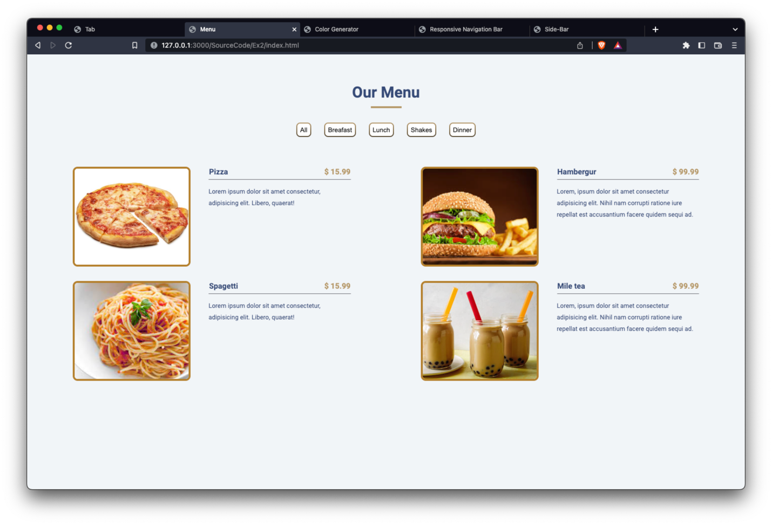

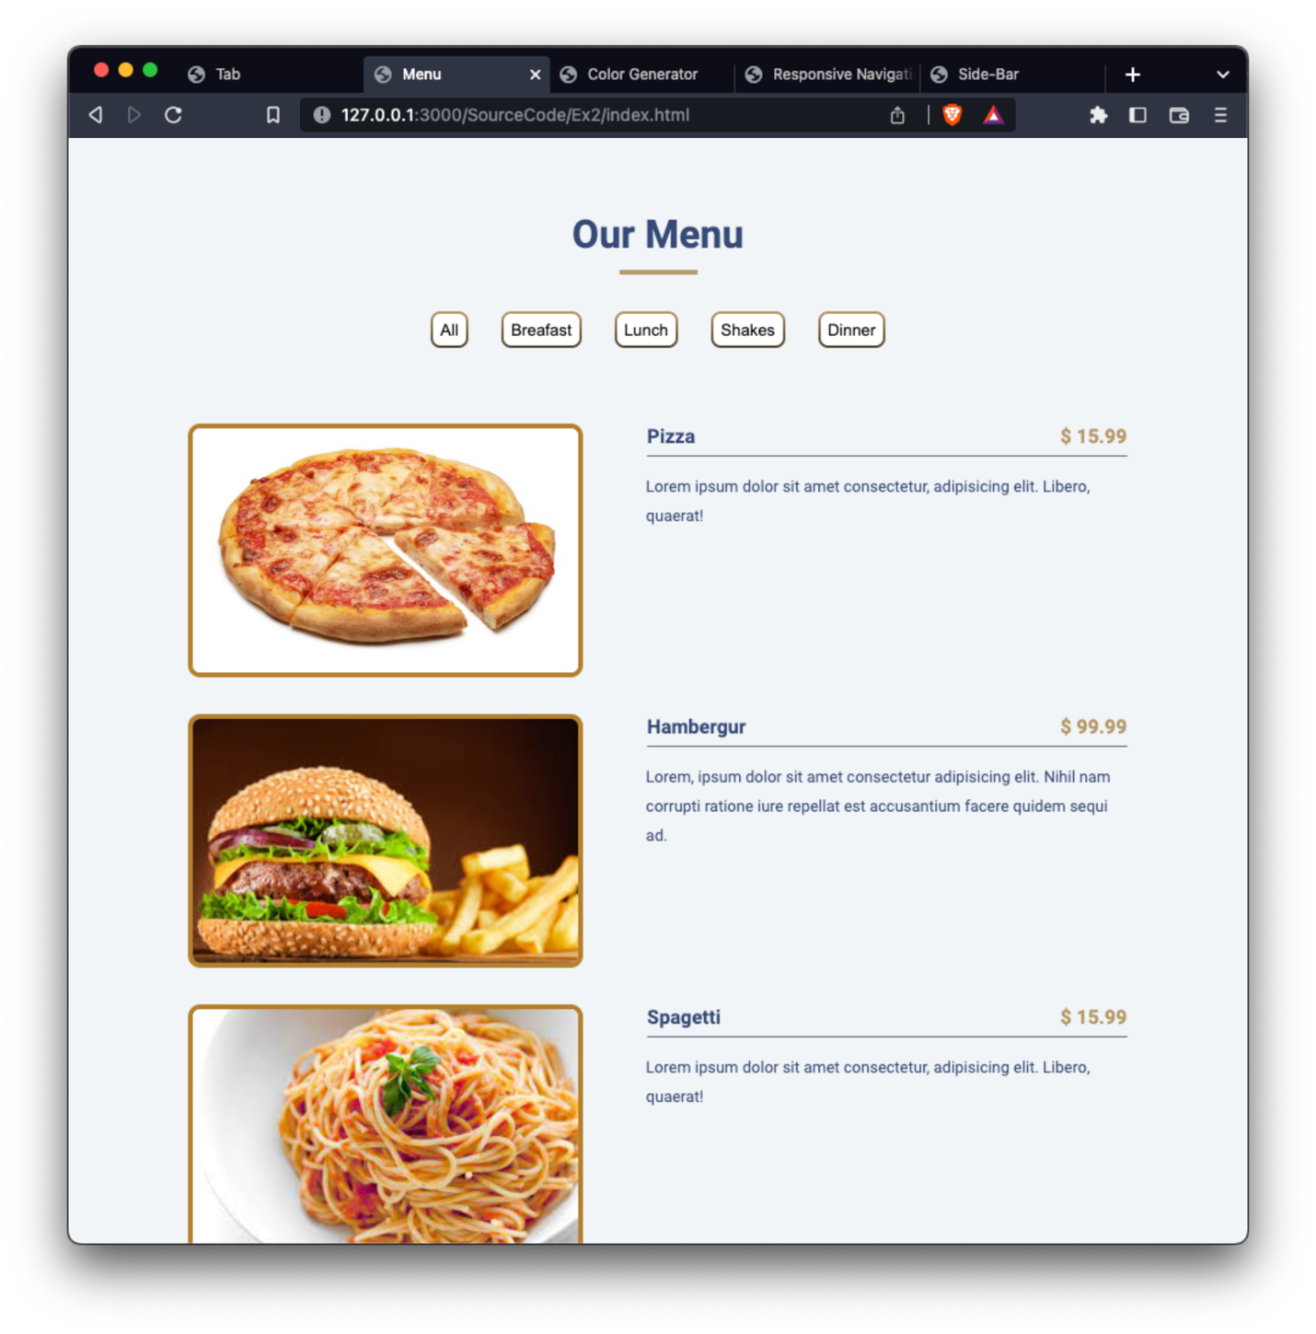

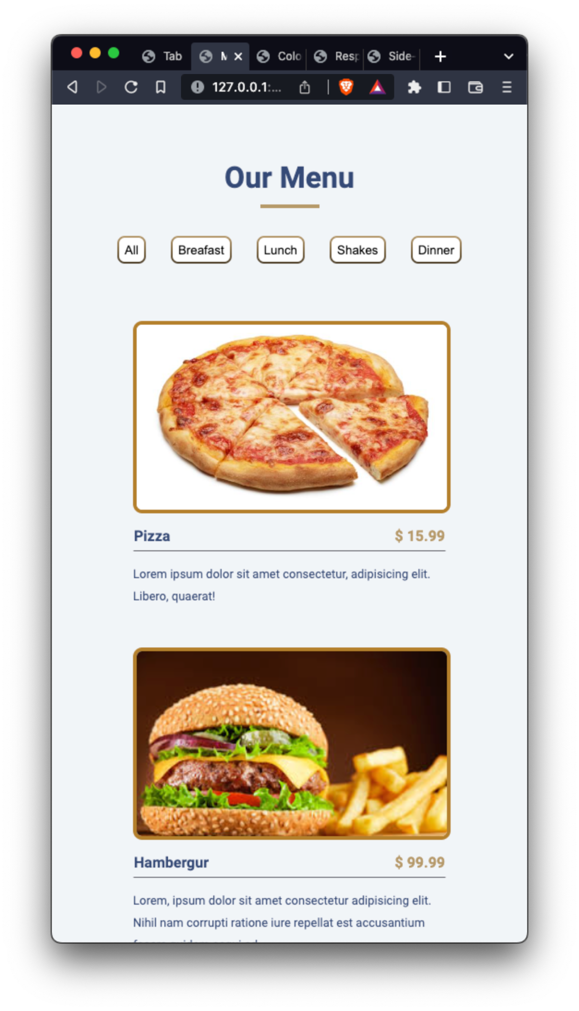

# **Exercise 3: Counter**

## **Index.html**

<!DOCTYPE html>

<html lang="en">

<head>

<meta charset="UTF-8">

<meta http-equiv="X-UA-Compatible" content="IE=edge">

<meta name="viewport" content="width=device-width, initial-scale=1.0">

<title>Counter</title>

<link rel="stylesheet" href="styles.css">

<script src="script.js"></script>

</head>

<body onload="load()">

<div class="wrapper">

<h3 class="title color1">Counter</h3>

<h1 class="number" id="displayNum">0</h1>

<div class="btn-container">

<button class="btn" onclick="decreaseBtnPresse()">DECREASE</button>

<button class="btn" onclick="reset()">RESET</button>

<button class="btn inc-btn" onclick="increaseBtnPresse()">INCREASE</button>

</div>

</div>

</body>

</html>

## **Styles.css**

body {

font-family: Arial, "Helvetica Neue", Helvetica, sans-serif;

}

.color1 {

color: #354a77;

}

.wrapper {

margin: auto;

margin-top: 20%;

text-align: center;

}

.title {

font-size: 48px;

}

.number {

font-size: 64px;

color: #008000;

}

.btn-container {

width: 270px;

margin: auto;

display: flex;

justify-content: space-between;

}

.btn {

border-radius: 4px;

background-color: rgb(255, 255, 255);

height: 30px;

}

.inc-btn {

background-color: #222121;

color: white;

}

## **Script.js**

var num = 0

var counterKey = "counter"

function load() {

readFromStorage()

display(num);

}

function increaseBtnPresse() {

num += 1;

display(num)

writeDataToStorage(num)

}

function decreaseBtnPresse() {

num -= 1;

display(num)

writeDataToStorage(num)

}

function reset() {

num = 0;

display(num)

writeDataToStorage(num)

}

function display(value) {

var displayNumber = document.getElementById("displayNum")

displayNumber.innerHTML = value;

if (num < 0) displayNumber.style.color = "#AF2F2F"

else displayNumber.style.color = "#008000"

}

function writeDataToStorage(value) {

localStorage.setItem(counterKey, value);

}

function readFromStorage() {

num = Number(localStorage.getItem(counterKey))

}

## **Result**

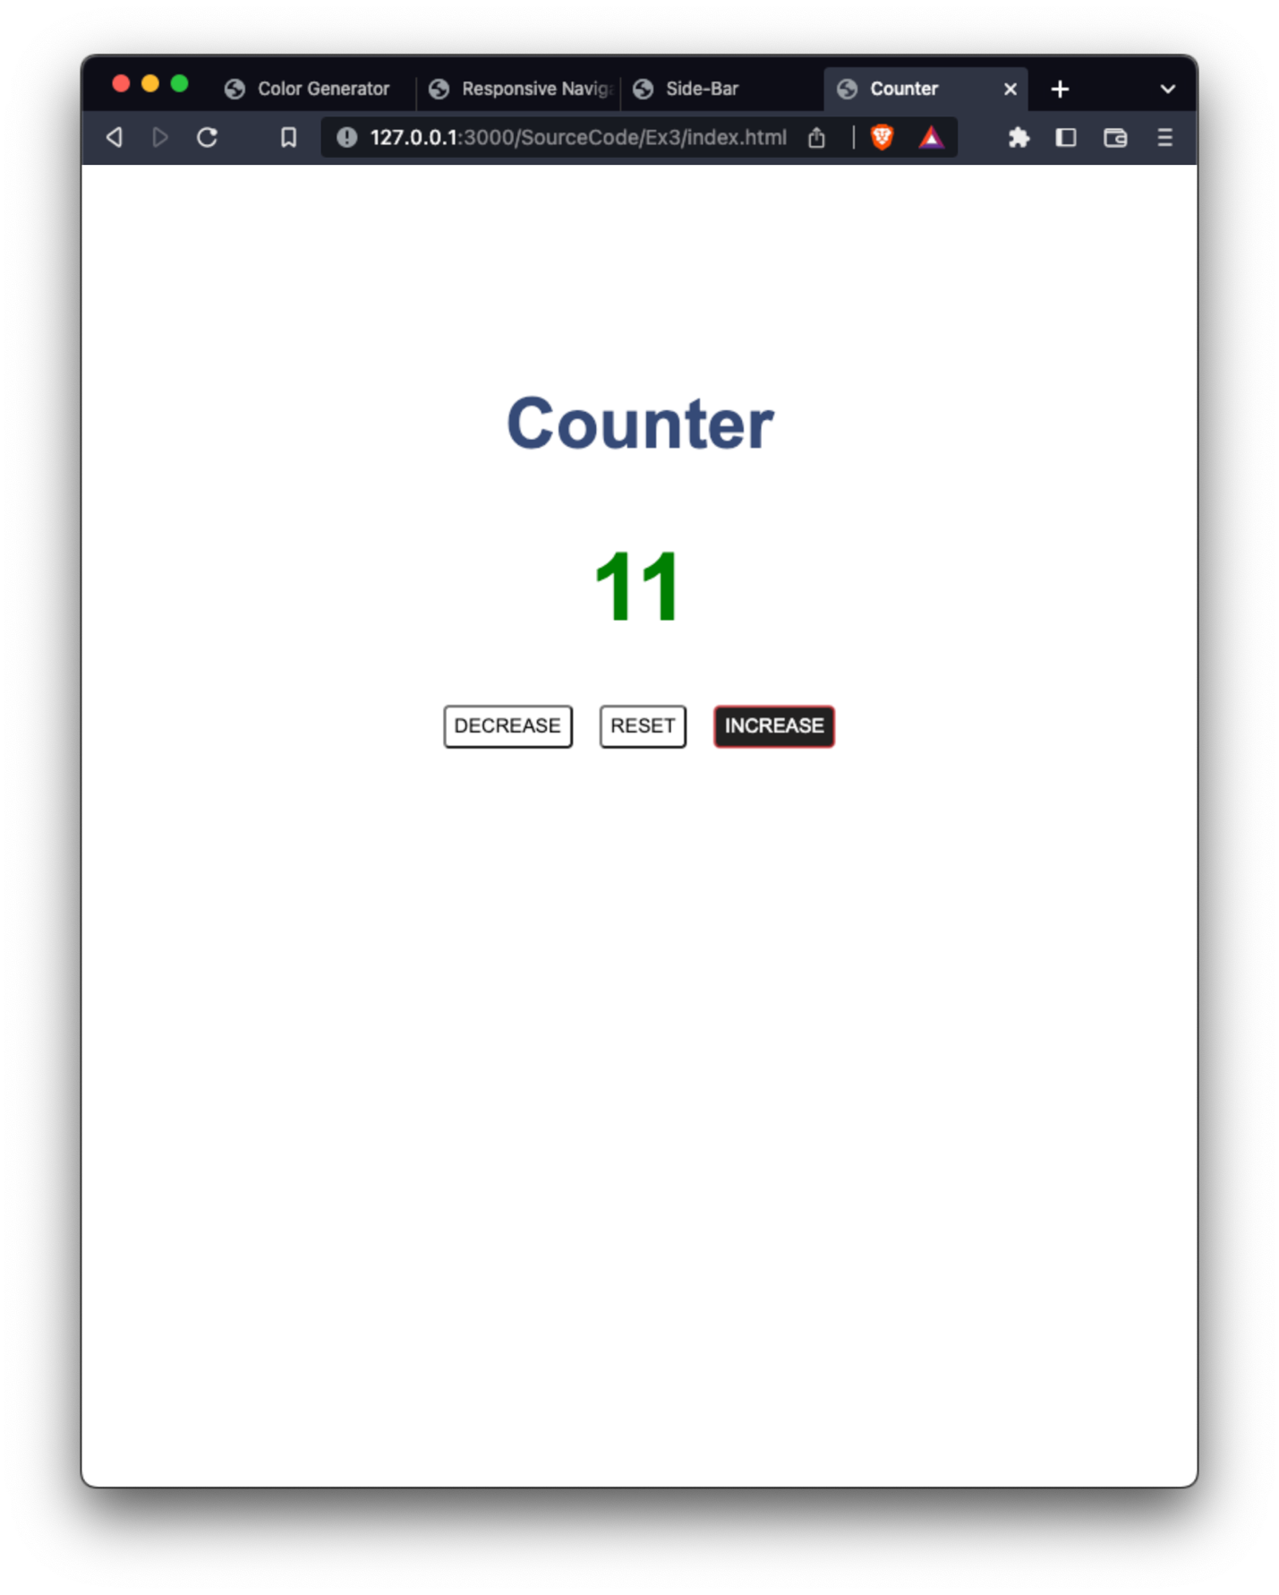

# **Exercise 4: Random color generator**

## **Index.html**

<!DOCTYPE html>

<html lang="en">

<head>

<meta charset="UTF-8">

<meta http-equiv="X-UA-Compatible" content="IE=edge">

<meta name="viewport" content="width=device-width, initial-scale=1.0">

<title>Color Generator</title>

<link rel="stylesheet" href="styles.css">

<script src="script.js"></script>

<link rel="preconnect" href="https://fonts.googleapis.com">

<link rel="preconnect" href="https://fonts.gstatic.com" crossorigin>

<link href="https://fonts.googleapis.com/css2?family=Inter:wght@100;200;300;400;500;600;700;800;900&display=swap" rel="stylesheet">

</head>

<body onload="getDataFromStorage()">

<div class="wrapper">

<div class="header" id="colorDiaplayer">

<h4 class="title">Ramdom color generator</h4>

</div>

<div class="main">

<div class="color-container" id="color-container">

<!-- <div class="element">

<div class="color" id="color-view"></div>

<p class="color-item" id="color-code">NaN</p>

</div> -->

</div>

</div>

</div>

<div class="upper">

<h2>Background Color:</h2>

<h1 id="colorHax">#NaN</h1>

<div class="btn-container">

<button class="btn generate-btn" onclick="generate()">GENERATE</button>

<button class="btn" onclick="reset()">RESET</button>

</div>

</div>

</body>

</html>

## **Styles.css**

body {

background-color: #C9C9C9;

font-family: 'Inter', sans-serif;

font-weight: 400;

}

.wrapper {

width: 450px;

height: 800px;

background-color: white;

margin: auto;

margin-top: 30px;

object-fit: cover;

}

.header {

width: 100%;

height: 250px;

background-color: #CE7171;

display: flex;

}

.title {

margin-top: 70px;

margin-left: auto;

margin-right: auto;

font-weight: 400;

}

.upper {

position: relative;

width: 350px;

height: 180px;

background-color: #C9C9C9;

border-radius: 10px;

top: -640px;

margin: auto;

padding: 1px;

text-align: center;

}

.btn-container {

width: 50%;

margin: auto;

display: flex;

justify-content: space-between;

}

.btn {

height: 30px;

width: auto;

border-radius: 5px;

border-color: #222222;

}

.generate-btn {

background-color: #222222;

color: white;

}

.main {

height: 550px;

/* background-color: #222222; */

}

.color-container {

width: 83%;

height: 80%;

margin: auto;

/* display: flex;

flex-wrap: wrap; */

/* flex-direction: row; */

margin-top: 100px;

text-align: left;

overflow-y: scroll;

}

.element {

display: inline-block;

width: 90px;

height: 40px;

margin-top: 10px;

}

.color {

display: inline-block;

background-color: #222222;

border-radius: 10px;

width: 15px;

height: 15px;

}

.color-item {

display: inline-block;

}

## **Script.js**

var strColor = ""

var colors = []

function generate() {

colorGenerator()

console.log(strColor)

colors.push(strColor);

console.log(colors)

displayCodeColor()

writeData()

}

function colorGenerator() {

const color = Math.floor(Math.random()*16777215).toString(16);

strColor = "#" + color;

}

function displayCodeColor() {

var view = document.getElementById("colorDiaplayer")

view.style.backgroundColor = strColor

document.getElementById("colorHax").innerHTML = strColor

document.getElementById("color-container").innerHTML = ""

colors.forEach(element => {

document.getElementById("color-container").innerHTML += `

<div class="element">

<div class="color" style="background-color:${element}"></div>

<p class="color-item">${element}</p>

</div>

</div>

`

});

}

function writeData() {

localStorage.setItem("colors", JSON.stringify(colors));

}

function getDataFromStorage() {

// var data =

colors = JSON.parse(localStorage.getItem("colors"))

strColor = colors[colors.length-1]

displayCodeColor()

}

function reset() {

colors = []

strColor = "NaN"

writeData()

displayCodeColor()

}

## **Result**

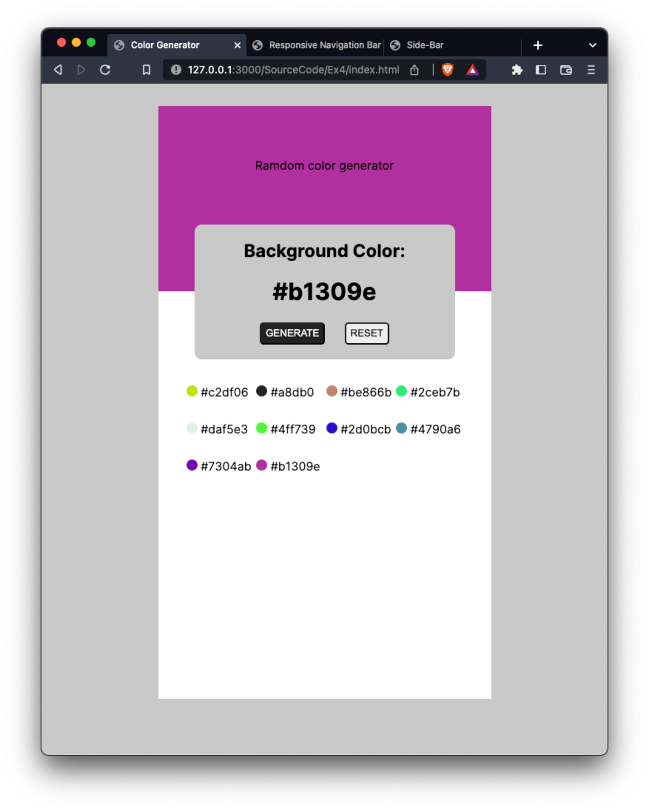

# **Exercise 5: Responsive Navigation Bar**

## **Index.html**

<!DOCTYPE html>

<html lang="en">

<head>

<meta charset="UTF-8">

<meta http-equiv="X-UA-Compatible" content="IE=edge">

<meta name="viewport" content="width=device-width, initial-scale=1.0">

<title>Responsive Navigation Bar</title>

<link rel="stylesheet" href="styles.css">

<link rel="preconnect" href="https://fonts.googleapis.com">

<link rel="preconnect" href="https://fonts.gstatic.com" crossorigin>

<link href="https://fonts.googleapis.com/css2?family=Inter:wght@100;200;300;400;500;600;700;800;900&display=swap" rel="stylesheet">

<link rel="stylesheet" href="https://cdn.jsdelivr.net/npm/bootstrap@4.0.0/dist/css/bootstrap.min.css" integrity="sha384-Gn5384xqQ1aoWXA+058RXPxPg6fy4IWvTNh0E263XmFcJlSAwiGgFAW/dAiS6JXm" crossorigin="anonymous">

</head>

<body>

<nav class="wrapper">

<h1 class="logo">NAV-BAR</h1>

<div class="dropdown">

<div class="dropdown-btn">

<svg viewBox="0 0 48 48" fill="none" xmlns="http://www.w3.org/2000/svg">

<path d="M42 15H6C4.35 15 3 13.65 3 12C3 10.35 4.35 9 6 9H42C43.65 9 45 10.35 45 12C45 13.65 43.65 15 42 15Z" fill="#49A6E9"/>

<path d="M42 27H6C4.35 27 3 25.65 3 24C3 22.35 4.35 21 6 21H42C43.65 21 45 22.35 45 24C45 25.65 43.65 27 42 27Z" fill="#49A6E9"/>

<path d="M42 39H6C4.35 39 3 37.65 3 36C3 34.35 4.35 33 6 33H42C43.65 33 45 34.35 45 36C45 37.65 43.65 39 42 39Z" fill="#49A6E9"/>

</svg>

</div>

<div class="item-container">

<a href="" class="nav-item">Home</a>

<a href="" class="nav-item">About</a>

<a href="" class="nav-item">Projects</a>

<a href="" class="nav-item">Contact</a>

</div>

</div>

<div class="icon-container">

<a href="">

<svg class="icon" viewBox="0 0 48 48" fill="none" xmlns="http://www.w3.org/2000/svg">

<path d="M24 5C18.9609 5 14.1282 7.00178 10.565 10.565C7.00178 14.1282 5 18.9609 5 24C5 29.0391 7.00178 33.8718 10.565 37.435C14.1282 40.9982 18.9609 43 24 43C29.0391 43 33.8718 40.9982 37.435 37.435C40.9982 33.8718 43 29.0391 43 24C43 18.9609 40.9982 14.1282 37.435 10.565C33.8718 7.00178 29.0391 5 24 5Z" fill="#49A6E9"/>

<path d="M26.572 29.036H31.489L32.261 24.041H26.571V21.311C26.571 19.236 27.249 17.396 29.19 17.396H32.309V13.037C31.761 12.963 30.602 12.801 28.412 12.801C23.839 12.801 21.158 15.216 21.158 20.718V24.041H16.457V29.036H21.158V42.765C22.089 42.905 23.032 43 24 43C24.875 43 25.729 42.92 26.572 42.806V29.036Z" fill="white"/>

</svg>

</a>

<a href="">

<svg class="icon" viewBox="0 0 48 48" fill="none" xmlns="http://www.w3.org/2000/svg">

<path d="M42 12.429C40.677 13.015 39.254 13.406 37.753 13.591C39.279 12.685 40.453 11.24 41.004 9.533C39.576 10.37 37.994 10.985 36.311 11.309C34.967 9.884 33.05 9 30.926 9C26.846 9 23.539 12.278 23.539 16.32C23.539 16.892 23.606 17.449 23.732 17.99C17.594 17.682 12.15 14.764 8.50801 10.336C7.86801 11.418 7.50801 12.685 7.50801 14.022C7.50801 16.563 8.80901 18.8 10.793 20.118C9.58201 20.081 8.44201 19.744 7.44401 19.204C7.44401 19.226 7.44401 19.259 7.44401 19.29C7.44401 22.841 9.99101 25.798 13.367 26.471C12.75 26.64 12.098 26.734 11.426 26.734C10.949 26.734 10.484 26.68 10.034 26.599C10.974 29.501 13.701 31.622 16.932 31.685C14.404 33.645 11.22 34.819 7.75801 34.819C7.16001 34.819 6.57501 34.785 5.99701 34.715C9.26801 36.786 13.152 38 17.321 38C30.906 38 38.338 26.844 38.338 17.166C38.338 16.849 38.328 16.533 38.313 16.221C39.763 15.197 41.013 13.905 42 12.429Z" fill="#49A6E9"/>

</svg>

</a>

<a href="">

<svg class="icon" viewBox="0 0 48 48" fill="none" xmlns="http://www.w3.org/2000/svg">

<path d="M6 10C6 7.791 7.791 6 10 6H38C40.209 6 42 7.791 42 10V38C42 40.209 40.209 42 38 42H10C7.791 42 6 40.209 6 38V10Z" fill="#49A6E9"/>

<path d="M27 17H34V19H27V17ZM21.512 23.428C22.097 23.143 23.415 22.494 23.415 20.571C23.415 16.954 19.463 17.001 18.732 17.001H12V31.001H19.025C19.61 31 24 30.835 24 26.999C24 24.524 22.39 23.714 21.512 23.428ZM15 19.428H17.928C18.22 19.428 20.123 19.532 20.123 21C20.123 22.467 18.66 22.714 18.221 22.714H15V19.428ZM18.336 28.571H14.969V24.715H18.336C19.067 24.715 20.677 24.952 20.677 26.715C20.677 28.476 18.628 28.571 18.336 28.571ZM32.438 28.395C31.973 28.684 31.509 28.831 30.889 28.831C28.563 28.831 28.1 26.87 28.1 26.001H36C36 25.132 36 24.49 35.845 23.765C35.689 23.04 34.63 20 30.734 20C25.289 20 25 24.778 25 25.5C25 26.223 25.156 27.093 25.467 27.671C25.776 28.395 26.086 28.975 26.551 29.407C27.015 29.842 27.634 30.273 28.254 30.564C29.028 30.855 29.803 31 30.578 31C31.816 31 32.902 30.712 33.831 30.132C34.762 29.553 35.381 28.684 35.845 27.526H33.212C33.057 27.816 32.902 28.104 32.438 28.395ZM30.734 22.027C32.252 22.027 32.902 23.619 33.056 24.341H28.1C28.1 24.198 28.471 22.027 30.734 22.027Z" fill="white"/>

</svg>

</a>

<a href="">

<svg class="icon" viewBox="0 0 48 48" fill="none" xmlns="http://www.w3.org/2000/svg">

<path d="M42 37C42 39.762 39.762 42 37 42H11C8.239 42 6 39.762 6 37V11C6 8.238 8.239 6 11 6H37C39.762 6 42 8.238 42 11V37Z" fill="#49A6E9"/>

<path d="M12 19H17V36H12V19ZM14.485 17H14.457C12.965 17 12 15.888 12 14.499C12 13.08 12.995 12 14.514 12C16.035 12 16.972 13.08 17 14.499C17 15.887 16.035 17 14.485 17ZM36 36H31V26.901C31 24.703 29.775 23.203 27.808 23.203C26.307 23.203 25.495 24.215 25.101 25.193C24.957 25.543 25 26.511 25 27V36H20V19H25V21.616C25.721 20.5 26.85 19 29.738 19C33.316 19 35.999 21.25 35.999 26.274L36 36Z" fill="white"/>

</svg>

</a>

<a href="">

<svg class="icon" viewBox="0 0 48 48" fill="none" xmlns="http://www.w3.org/2000/svg">

<path d="M33 17H43L24 42L33 17Z" fill="#0D47A1"/>

<path d="M5 17L15 5V17H5Z" fill="#1976D2"/>

<path d="M33 5V17H43L33 5Z" fill="#1976D2"/>

<path d="M15 17L23.996 42.149L33 17H15ZM15 5H24L15 17V5ZM24 5L33 17V5H24Z" fill="#0091EA"/>

<path d="M33 17H15L24 5L33 17ZM33 17L38 15L43 17L38 19L33 17Z" fill="#00B0FF"/>

<path d="M15 17H5L23.996 42.149L15 17ZM15 17L24 15L33 17L24 19L15 17Z" fill="#0D47A1"/>

<path d="M5 17L10 15L15 17L10 19L5 17Z" fill="#00B0FF"/>

</svg>

</a>

</div>

</nav>

</body>

</html>

## **Styles.css**

body {

background-color: #F1F5F8;

font-family: 'Inter', sans-serif;

}

.logo {

display: inline-block;

font-weight: 500;

font-size: xx-large;

margin-top: 9px;

margin-left: 30px;

}

.wrapper {

height: 60px;

background-color: white;

display: flex;

justify-content: space-between;

align-items: center;

/* padding: 1rem; */

box-shadow: 2px 2px 10px rgb(211, 211, 211);

}

/* Button */

.item-container {

/* display: inline-block; */

width: 300px;

display: flex;

justify-content: space-between;

}

.nav-item {

color: #8CA4BE;

font-weight: 400;

text-decoration: none;

}

.icon-container {

/* display: inline-block; */

display: flex;

}

.icon {

display: inline-block;

width: 20px;

height: 20px;

margin-right: 9px;

}

.dropdown {

height: 100%;

margin-top: 30px;

margin-right: 20px;

display: inline;

}

.dropdown-btn {

display: none;

width: 25px;

height: 25px;

}

.dropdown-btn:hover {

cursor: pointer;

}

@media only screen and (max-width: 900px) {

.icon-container {

display: none;

}

}

@media only screen and (max-width: 500px) {

.logo {

font-size: larger;

}

.icon-container {

display: none;

}

.dropdown {

height: 100%;

float: right;

}

.item-container {

display: none;

background-color: white;

top: 45px;

right: -20px;

width: 100vw;

position: absolute;

/* width: 100%; */

box-shadow: 0px 8px 10px rgba(0,0,0,0.2);

z-index: 1;

}

.nav-item {

float: none;

padding: 12px 16px;

text-decoration: none;

display: block;

text-align: left;

}

.dropdown-btn {

display: inline-block;

}

.dropdown:hover .item-container {

display: block;

}

.dropdown:hover .dropdown-btn {

transform: rotate(90deg);

}

.nav-item:hover {

background-color: #d5dde6;

color: #8CA4BE;

}

}

## **Result**

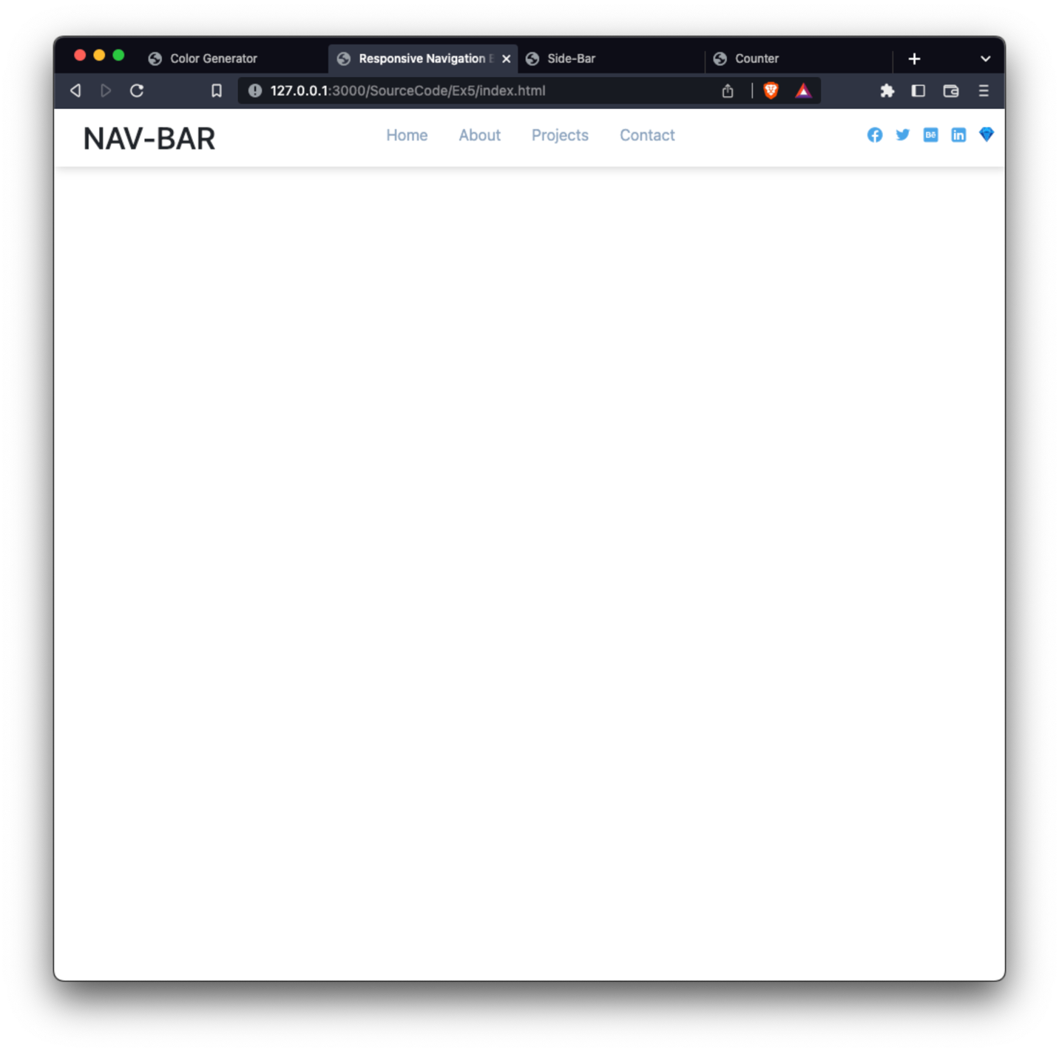

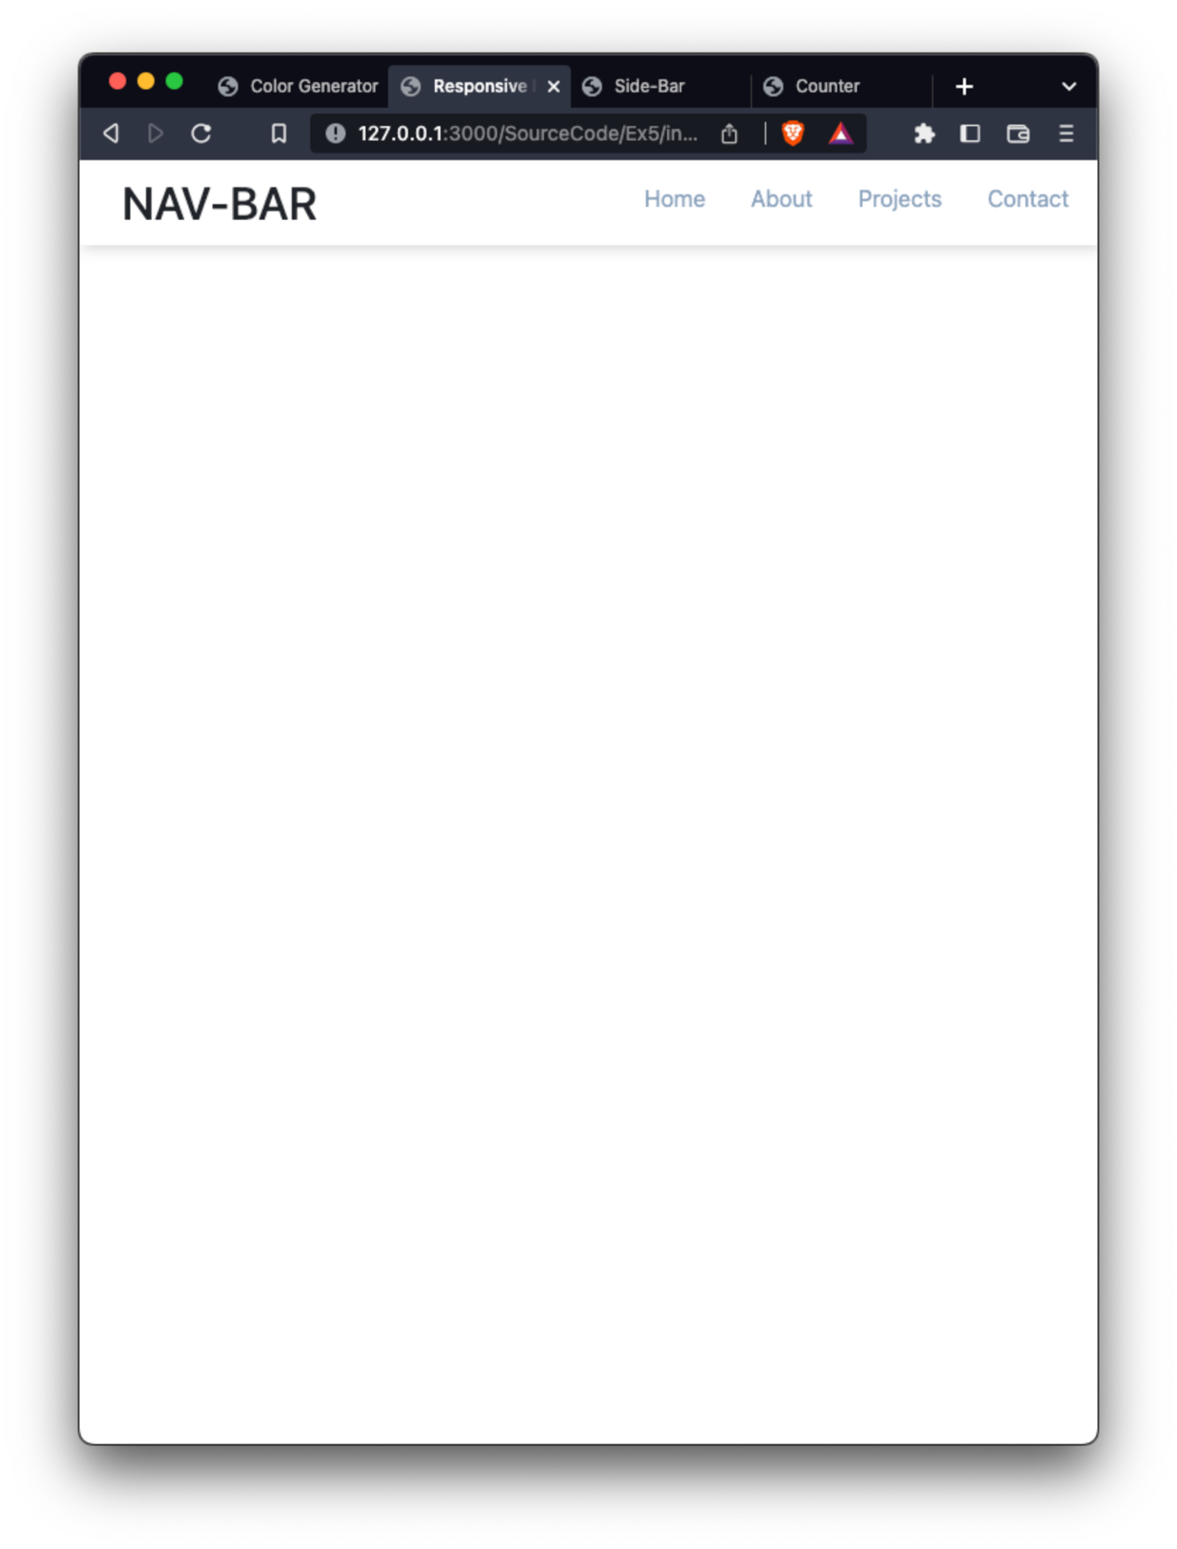

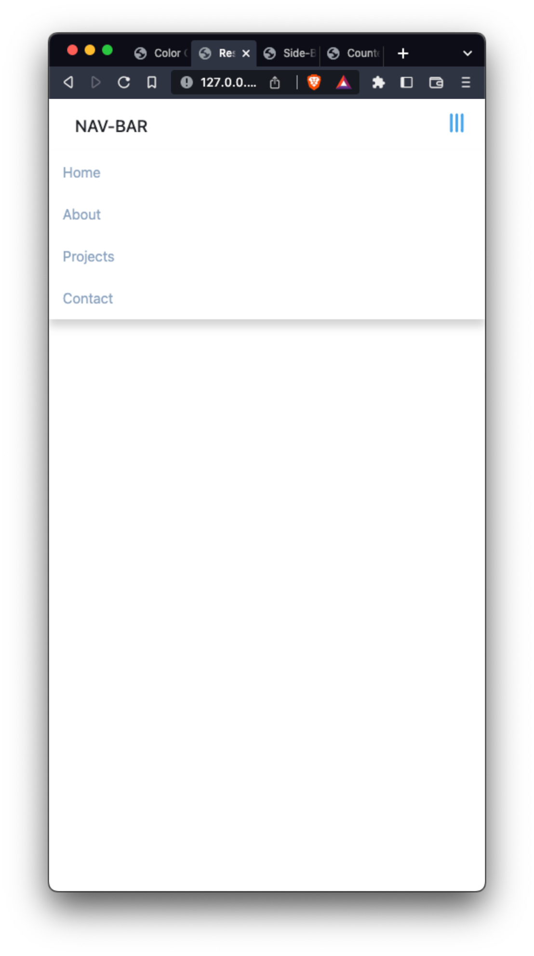

# **Exercise 6: Side Bar**

## **Index.html**

<!DOCTYPE html>

<html lang="en">

<head>

<meta charset="UTF-8">

<meta http-equiv="X-UA-Compatible" content="IE=edge">

<meta name="viewport" content="width=device-width, initial-scale=1.0">

<title>Side-Bar</title>

<link rel="stylesheet" href="styles.css">

<script src="script.js"></script>

</head>

<body>

<div class="wrapper">

<button class="btn" id="show-btn" onclick="showSidebar()">

<svg viewBox="0 0 48 48" fill="none" xmlns="http://www.w3.org/2000/svg">

<path d="M42 15H6C4.35 15 3 13.65 3 12C3 10.35 4.35 9 6 9H42C43.65 9 45 10.35 45 12C45 13.65 43.65 15 42 15Z" fill="#49A6E9"/>

<path d="M42 27H6C4.35 27 3 25.65 3 24C3 22.35 4.35 21 6 21H42C43.65 21 45 22.35 45 24C45 25.65 43.65 27 42 27Z" fill="#49A6E9"/>

<path d="M42 39H6C4.35 39 3 37.65 3 36C3 34.35 4.35 33 6 33H42C43.65 33 45 34.35 45 36C45 37.65 43.65 39 42 39Z" fill="#49A6E9"/>

</svg>

</button>

<div id="sideBar-wrapper">

<div class="sideBar-header">

<div class="logo-container">

<svg class="logo" viewBox="0 0 83 17" fill="none" xmlns="http://www.w3.org/2000/svg">

<path d="M9.27344 5.27557C9.19768 4.60322 8.88518 4.08239 8.33594 3.71307C7.7867 3.33902 7.09541 3.15199 6.26207 3.15199C5.66548 3.15199 5.14938 3.24669 4.71378 3.43608C4.27817 3.62074 3.93963 3.87642 3.69815 4.20312C3.46141 4.52509 3.34304 4.89205 3.34304 5.30398C3.34304 5.64962 3.42353 5.94792 3.58452 6.19886C3.75024 6.44981 3.96567 6.66051 4.23082 6.83097C4.50071 6.99669 4.78954 7.13636 5.0973 7.25C5.40507 7.3589 5.70099 7.44886 5.98509 7.51989L7.40554 7.8892C7.86955 8.00284 8.34541 8.15672 8.8331 8.35085C9.32079 8.54498 9.77296 8.80066 10.1896 9.1179C10.6063 9.43513 10.9425 9.82812 11.1982 10.2969C11.4586 10.7656 11.5888 11.3267 11.5888 11.9801C11.5888 12.804 11.3757 13.5355 10.9496 14.1747C10.5282 14.8139 9.91501 15.3182 9.11009 15.6875C8.3099 16.0568 7.34162 16.2415 6.20526 16.2415C5.11624 16.2415 4.17401 16.0687 3.37855 15.723C2.5831 15.3774 1.96046 14.8873 1.51065 14.2528C1.06084 13.6136 0.812263 12.8561 0.764915 11.9801H2.96662C3.00923 12.5057 3.17969 12.9437 3.47798 13.294C3.78101 13.6397 4.1669 13.8977 4.63565 14.0682C5.10914 14.2339 5.6276 14.3168 6.19105 14.3168C6.81132 14.3168 7.36293 14.2197 7.84588 14.0256C8.33357 13.8267 8.71709 13.5521 8.99645 13.2017C9.27581 12.8466 9.41548 12.4323 9.41548 11.9588C9.41548 11.5279 9.29238 11.1752 9.04616 10.9006C8.80469 10.6259 8.47562 10.3987 8.05895 10.2188C7.64702 10.0388 7.18063 9.88021 6.6598 9.7429L4.94105 9.27415C3.77628 8.95691 2.85298 8.49053 2.17116 7.875C1.49408 7.25947 1.15554 6.44508 1.15554 5.43182C1.15554 4.59375 1.38281 3.86222 1.83736 3.23722C2.2919 2.61222 2.90743 2.12689 3.68395 1.78125C4.46046 1.43087 5.33641 1.25568 6.31179 1.25568C7.29664 1.25568 8.16548 1.4285 8.91832 1.77415C9.6759 2.11979 10.2725 2.59564 10.7081 3.2017C11.1437 3.80303 11.371 4.49432 11.3899 5.27557H9.27344ZM14.0408 16V5.09091H16.1644V16H14.0408ZM15.1133 3.40767C14.744 3.40767 14.4267 3.28456 14.1616 3.03835C13.9012 2.7874 13.771 2.48911 13.771 2.14347C13.771 1.79309 13.9012 1.49479 14.1616 1.24858C14.4267 0.997632 14.744 0.872159 15.1133 0.872159C15.4826 0.872159 15.7975 0.997632 16.0579 1.24858C16.323 1.49479 16.4556 1.79309 16.4556 2.14347C16.4556 2.48911 16.323 2.7874 16.0579 3.03835C15.7975 3.28456 15.4826 3.40767 15.1133 3.40767ZM23.1051 16.2131C22.2244 16.2131 21.4384 15.9882 20.7472 15.5384C20.0606 15.0838 19.5208 14.4375 19.1278 13.5994C18.7396 12.7566 18.5455 11.7457 18.5455 10.5668C18.5455 9.38778 18.742 8.37926 19.1349 7.54119C19.5327 6.70312 20.0772 6.06155 20.7685 5.61648C21.4598 5.1714 22.2434 4.94886 23.1193 4.94886C23.7964 4.94886 24.3409 5.0625 24.7528 5.28977C25.1695 5.51231 25.4915 5.77273 25.7188 6.07102C25.9508 6.36932 26.1307 6.6321 26.2585 6.85938H26.3864V1.45455H28.5099V16H26.4361V14.3026H26.2585C26.1307 14.5346 25.946 14.7997 25.7045 15.098C25.4678 15.3963 25.1411 15.6567 24.7244 15.8793C24.3078 16.1018 23.768 16.2131 23.1051 16.2131ZM23.5739 14.402C24.1847 14.402 24.7008 14.241 25.1222 13.919C25.5483 13.5923 25.8703 13.1402 26.0881 12.5625C26.3106 11.9848 26.4219 11.3125 26.4219 10.5455C26.4219 9.78788 26.313 9.125 26.0952 8.55682C25.8774 7.98864 25.5578 7.54593 25.1364 7.22869C24.715 6.91146 24.1941 6.75284 23.5739 6.75284C22.9347 6.75284 22.402 6.91856 21.9759 7.25C21.5497 7.58144 21.2277 8.03362 21.0099 8.60653C20.7969 9.17945 20.6903 9.82576 20.6903 10.5455C20.6903 11.2746 20.7992 11.9304 21.017 12.5128C21.2348 13.0952 21.5568 13.5568 21.983 13.8977C22.4138 14.2339 22.9441 14.402 23.5739 14.402ZM36.2425 16.2202C35.1677 16.2202 34.2421 15.9905 33.4656 15.5312C32.6938 15.0672 32.0972 14.4162 31.6758 13.5781C31.2591 12.7353 31.0508 11.7481 31.0508 10.6165C31.0508 9.49905 31.2591 8.5142 31.6758 7.66193C32.0972 6.80966 32.6843 6.14441 33.4371 5.66619C34.1947 5.18797 35.0801 4.94886 36.0934 4.94886C36.7089 4.94886 37.3055 5.05066 37.8832 5.25426C38.4608 5.45786 38.9793 5.77746 39.4386 6.21307C39.8978 6.64867 40.2601 7.21449 40.5252 7.91051C40.7904 8.6018 40.9229 9.44223 40.9229 10.4318V11.1847H32.2511V9.59375H38.842C38.842 9.03504 38.7283 8.54025 38.5011 8.10938C38.2738 7.67377 37.9542 7.33049 37.5423 7.07955C37.1351 6.8286 36.6568 6.70312 36.1076 6.70312C35.511 6.70312 34.9902 6.84991 34.5451 7.14347C34.1048 7.43229 33.7638 7.81108 33.5224 8.27983C33.2856 8.74384 33.1673 9.24811 33.1673 9.79261V11.0355C33.1673 11.7647 33.2951 12.3849 33.5508 12.8963C33.8112 13.4077 34.1734 13.7983 34.6374 14.0682C35.1014 14.3333 35.6436 14.4659 36.2638 14.4659C36.6663 14.4659 37.0333 14.4091 37.3647 14.2955C37.6961 14.1771 37.9826 14.0019 38.2241 13.7699C38.4656 13.5379 38.6502 13.2514 38.7781 12.9105L40.788 13.2727C40.627 13.8646 40.3382 14.383 39.9215 14.8281C39.5096 15.2685 38.9911 15.6117 38.3661 15.858C37.7459 16.0994 37.038 16.2202 36.2425 16.2202ZM49.7067 8.93324V10.7727H43.2578V8.93324H49.7067ZM52.7074 16V1.45455H58.0341C59.0663 1.45455 59.9209 1.625 60.598 1.96591C61.2751 2.30208 61.7817 2.759 62.1179 3.33665C62.4541 3.90956 62.6222 4.55587 62.6222 5.27557C62.6222 5.88163 62.5109 6.39299 62.2884 6.80966C62.0658 7.22159 61.7675 7.55303 61.3935 7.80398C61.0241 8.05019 60.617 8.23011 60.1719 8.34375V8.4858C60.6548 8.50947 61.1259 8.66572 61.5852 8.95455C62.0492 9.23864 62.4328 9.64347 62.7358 10.169C63.0388 10.6946 63.1903 11.3338 63.1903 12.0866C63.1903 12.83 63.0152 13.4976 62.6648 14.0895C62.3191 14.6766 61.7841 15.143 61.0597 15.4886C60.3352 15.8295 59.4096 16 58.2827 16H52.7074ZM54.902 14.1179H58.0696C59.1207 14.1179 59.8736 13.9143 60.3281 13.5071C60.7827 13.0999 61.0099 12.5909 61.0099 11.9801C61.0099 11.5208 60.8939 11.0994 60.6619 10.7159C60.4299 10.3324 60.0985 10.027 59.6676 9.79972C59.2415 9.57244 58.7348 9.45881 58.1477 9.45881H54.902V14.1179ZM54.902 7.74716H57.8423C58.3348 7.74716 58.7775 7.65246 59.1705 7.46307C59.5682 7.27367 59.883 7.00852 60.1151 6.66761C60.3518 6.32197 60.4702 5.91477 60.4702 5.44602C60.4702 4.8447 60.2595 4.34044 59.8381 3.93324C59.4167 3.52604 58.7704 3.32244 57.8991 3.32244H54.902V7.74716ZM68.7976 16.2415C68.1063 16.2415 67.4813 16.1136 66.9226 15.858C66.3639 15.5975 65.9212 15.2211 65.5945 14.7287C65.2725 14.2363 65.1115 13.6326 65.1115 12.9176C65.1115 12.3021 65.2299 11.7955 65.4666 11.3977C65.7034 11 66.023 10.6851 66.4254 10.4531C66.8279 10.2211 67.2777 10.0459 67.7749 9.92756C68.272 9.80919 68.7786 9.71922 69.2947 9.65767C69.9482 9.58191 70.4785 9.52036 70.8857 9.47301C71.2929 9.42093 71.5888 9.33807 71.7734 9.22443C71.9581 9.1108 72.0504 8.92614 72.0504 8.67045V8.62074C72.0504 8.00047 71.8752 7.51989 71.5249 7.17898C71.1792 6.83807 70.6631 6.66761 69.9766 6.66761C69.2616 6.66761 68.6982 6.82623 68.2862 7.14347C67.879 7.45597 67.5973 7.80398 67.4411 8.1875L65.4453 7.73295C65.6821 7.07008 66.0277 6.53504 66.4822 6.12784C66.9415 5.71591 67.4695 5.41761 68.0661 5.23295C68.6626 5.04356 69.29 4.94886 69.9482 4.94886C70.3838 4.94886 70.8454 5.00095 71.3331 5.10511C71.8255 5.20455 72.2848 5.3892 72.7109 5.65909C73.1418 5.92898 73.4946 6.31487 73.7692 6.81676C74.0438 7.31392 74.1811 7.96023 74.1811 8.75568V16H72.1072V14.5085H72.022C71.8847 14.7831 71.6787 15.053 71.4041 15.3182C71.1295 15.5833 70.7768 15.8035 70.3459 15.9787C69.915 16.1539 69.3989 16.2415 68.7976 16.2415ZM69.2592 14.5369C69.8464 14.5369 70.3482 14.4209 70.7649 14.1889C71.1863 13.9569 71.5059 13.6539 71.7237 13.2798C71.9463 12.901 72.0575 12.4962 72.0575 12.0653V10.6591C71.9818 10.7348 71.835 10.8059 71.6172 10.8722C71.4041 10.9337 71.1603 10.9882 70.8857 11.0355C70.611 11.0781 70.3435 11.1184 70.0831 11.1562C69.8227 11.1894 69.6049 11.2178 69.4297 11.2415C69.0178 11.2936 68.6413 11.3812 68.3004 11.5043C67.9643 11.6274 67.6944 11.8049 67.4908 12.0369C67.2919 12.2642 67.1925 12.5672 67.1925 12.946C67.1925 13.4716 67.3866 13.8693 67.7749 14.1392C68.1631 14.4044 68.6579 14.5369 69.2592 14.5369ZM77.0096 16V5.09091H79.0621V6.82386H79.1758C79.3746 6.23674 79.725 5.77509 80.2269 5.43892C80.7335 5.09801 81.3065 4.92756 81.9457 4.92756C82.0782 4.92756 82.2345 4.93229 82.4144 4.94176C82.5991 4.95123 82.7435 4.96307 82.8477 4.97727V7.00852C82.7624 6.98485 82.6109 6.95881 82.3931 6.9304C82.1753 6.89725 81.9575 6.88068 81.7397 6.88068C81.2378 6.88068 80.7904 6.98722 80.3974 7.20028C80.0091 7.40862 79.7013 7.69981 79.4741 8.07386C79.2468 8.44318 79.1332 8.86458 79.1332 9.33807V16H77.0096Z" fill="black"/>

</svg>

</div>

<button class="dismiss-btn btn" onclick="dismissSidebar()">

<svg viewBox="0 0 48 48" fill="none" xmlns="http://www.w3.org/2000/svg">

<path d="M36.144 41.179C35.9469 41.1794 35.7516 41.1407 35.5695 41.0652C35.3874 40.9896 35.222 40.8788 35.083 40.739L24 29.656L12.917 40.739C12.6357 41.0202 12.2542 41.1781 11.8565 41.1781C11.4588 41.1781 11.0773 41.0202 10.796 40.739L7.261 37.2C6.9798 36.9187 6.82182 36.5372 6.82182 36.1395C6.82182 35.7417 6.9798 35.3602 7.261 35.079L18.344 24L7.261 12.917C6.9798 12.6357 6.82182 12.2542 6.82182 11.8565C6.82182 11.4587 6.9798 11.0772 7.261 10.796L10.8 7.26096C11.0813 6.97975 11.4628 6.82178 11.8605 6.82178C12.2582 6.82178 12.6397 6.97975 12.921 7.26096L24 18.344L35.083 7.26096C35.3643 6.97975 35.7458 6.82178 36.1435 6.82178C36.5413 6.82178 36.9227 6.97975 37.204 7.26096L40.739 10.8C41.0202 11.0812 41.1782 11.4627 41.1782 11.8605C41.1782 12.2582 41.0202 12.6397 40.739 12.921L29.656 24L40.739 35.083C41.0202 35.3642 41.1782 35.7457 41.1782 36.1435C41.1782 36.5412 41.0202 36.9227 40.739 37.204L37.2 40.739C37.0616 40.8782 36.8971 40.9888 36.7159 41.0643C36.5347 41.1398 36.3403 41.1788 36.144 41.179Z" fill="url(#paint0_linear_173_102)"/>

<defs>

<linearGradient id="paint0_linear_173_102" x1="24" y1="6.82096" x2="24" y2="41.179" gradientUnits="userSpaceOnUse">

<stop stop-color="#F85E55"/>

<stop offset="1" stop-color="#D41414"/>

</linearGradient>

</defs>

</svg>

</button>

</div>

<div class="main">

<a href="">Home</a>

<a href="">About</a>

<a href="">Projects</a>

<a href="">Contact</a>

</div>

<div class="footer-sidebar">

<div class="icon-container">

<a href="">

<svg class="icon" viewBox="0 0 48 48" fill="none" xmlns="http://www.w3.org/2000/svg">

<path d="M24 5C18.9609 5 14.1282 7.00178 10.565 10.565C7.00178 14.1282 5 18.9609 5 24C5 29.0391 7.00178 33.8718 10.565 37.435C14.1282 40.9982 18.9609 43 24 43C29.0391 43 33.8718 40.9982 37.435 37.435C40.9982 33.8718 43 29.0391 43 24C43 18.9609 40.9982 14.1282 37.435 10.565C33.8718 7.00178 29.0391 5 24 5Z" fill="#49A6E9"/>

<path d="M26.572 29.036H31.489L32.261 24.041H26.571V21.311C26.571 19.236 27.249 17.396 29.19 17.396H32.309V13.037C31.761 12.963 30.602 12.801 28.412 12.801C23.839 12.801 21.158 15.216 21.158 20.718V24.041H16.457V29.036H21.158V42.765C22.089 42.905 23.032 43 24 43C24.875 43 25.729 42.92 26.572 42.806V29.036Z" fill="white"/>

</svg>

</a>

<a href="">

<svg class="icon" viewBox="0 0 48 48" fill="none" xmlns="http://www.w3.org/2000/svg">

<path d="M42 12.429C40.677 13.015 39.254 13.406 37.753 13.591C39.279 12.685 40.453 11.24 41.004 9.533C39.576 10.37 37.994 10.985 36.311 11.309C34.967 9.884 33.05 9 30.926 9C26.846 9 23.539 12.278 23.539 16.32C23.539 16.892 23.606 17.449 23.732 17.99C17.594 17.682 12.15 14.764 8.50801 10.336C7.86801 11.418 7.50801 12.685 7.50801 14.022C7.50801 16.563 8.80901 18.8 10.793 20.118C9.58201 20.081 8.44201 19.744 7.44401 19.204C7.44401 19.226 7.44401 19.259 7.44401 19.29C7.44401 22.841 9.99101 25.798 13.367 26.471C12.75 26.64 12.098 26.734 11.426 26.734C10.949 26.734 10.484 26.68 10.034 26.599C10.974 29.501 13.701 31.622 16.932 31.685C14.404 33.645 11.22 34.819 7.75801 34.819C7.16001 34.819 6.57501 34.785 5.99701 34.715C9.26801 36.786 13.152 38 17.321 38C30.906 38 38.338 26.844 38.338 17.166C38.338 16.849 38.328 16.533 38.313 16.221C39.763 15.197 41.013 13.905 42 12.429Z" fill="#49A6E9"/>

</svg>

</a>

<a href="">

<svg class="icon" viewBox="0 0 48 48" fill="none" xmlns="http://www.w3.org/2000/svg">

<path d="M6 10C6 7.791 7.791 6 10 6H38C40.209 6 42 7.791 42 10V38C42 40.209 40.209 42 38 42H10C7.791 42 6 40.209 6 38V10Z" fill="#49A6E9"/>

<path d="M27 17H34V19H27V17ZM21.512 23.428C22.097 23.143 23.415 22.494 23.415 20.571C23.415 16.954 19.463 17.001 18.732 17.001H12V31.001H19.025C19.61 31 24 30.835 24 26.999C24 24.524 22.39 23.714 21.512 23.428ZM15 19.428H17.928C18.22 19.428 20.123 19.532 20.123 21C20.123 22.467 18.66 22.714 18.221 22.714H15V19.428ZM18.336 28.571H14.969V24.715H18.336C19.067 24.715 20.677 24.952 20.677 26.715C20.677 28.476 18.628 28.571 18.336 28.571ZM32.438 28.395C31.973 28.684 31.509 28.831 30.889 28.831C28.563 28.831 28.1 26.87 28.1 26.001H36C36 25.132 36 24.49 35.845 23.765C35.689 23.04 34.63 20 30.734 20C25.289 20 25 24.778 25 25.5C25 26.223 25.156 27.093 25.467 27.671C25.776 28.395 26.086 28.975 26.551 29.407C27.015 29.842 27.634 30.273 28.254 30.564C29.028 30.855 29.803 31 30.578 31C31.816 31 32.902 30.712 33.831 30.132C34.762 29.553 35.381 28.684 35.845 27.526H33.212C33.057 27.816 32.902 28.104 32.438 28.395ZM30.734 22.027C32.252 22.027 32.902 23.619 33.056 24.341H28.1C28.1 24.198 28.471 22.027 30.734 22.027Z" fill="white"/>

</svg>

</a>

<a href="">

<svg class="icon" viewBox="0 0 48 48" fill="none" xmlns="http://www.w3.org/2000/svg">

<path d="M42 37C42 39.762 39.762 42 37 42H11C8.239 42 6 39.762 6 37V11C6 8.238 8.239 6 11 6H37C39.762 6 42 8.238 42 11V37Z" fill="#49A6E9"/>

<path d="M12 19H17V36H12V19ZM14.485 17H14.457C12.965 17 12 15.888 12 14.499C12 13.08 12.995 12 14.514 12C16.035 12 16.972 13.08 17 14.499C17 15.887 16.035 17 14.485 17ZM36 36H31V26.901C31 24.703 29.775 23.203 27.808 23.203C26.307 23.203 25.495 24.215 25.101 25.193C24.957 25.543 25 26.511 25 27V36H20V19H25V21.616C25.721 20.5 26.85 19 29.738 19C33.316 19 35.999 21.25 35.999 26.274L36 36Z" fill="white"/>

</svg>

</a>

<a href="">

<svg class="icon" viewBox="0 0 48 48" fill="none" xmlns="http://www.w3.org/2000/svg">

<path d="M33 17H43L24 42L33 17Z" fill="#0D47A1"/>

<path d="M5 17L15 5V17H5Z" fill="#1976D2"/>

<path d="M33 5V17H43L33 5Z" fill="#1976D2"/>

<path d="M15 17L23.996 42.149L33 17H15ZM15 5H24L15 17V5ZM24 5L33 17V5H24Z" fill="#0091EA"/>

<path d="M33 17H15L24 5L33 17ZM33 17L38 15L43 17L38 19L33 17Z" fill="#00B0FF"/>

<path d="M15 17H5L23.996 42.149L15 17ZM15 17L24 15L33 17L24 19L15 17Z" fill="#0D47A1"/>

<path d="M5 17L10 15L15 17L10 19L5 17Z" fill="#00B0FF"/>

</svg>

</a>

</div>

</div>

</div>

</div>

</body>

</html>

## **Styles.css**

body {

background-color: #F1F5F8;

font-family: 'Inter', sans-serif;

}

.btn {

cursor: pointer;

width: 50px;

height: 50px;

border: none;

background-color: transparent;

}

#show-btn {

position: absolute;

right: 10px;

}

#sideBar-wrapper {

display: none;

padding-top: 10px;

position: absolute;

top: 0px;

bottom: 0px;

left: 0px;

width: 340px;

/* height: 100%; */

background-color: white;

}

.sideBar-header {

padding: 10px;

display: flex;

justify-content: space-between;

}

.logo-container {

display: inline-block;

display: flex;

width: 100px;

height: 40px;

}

.dismiss-btn {

/* display: flex; */

display: inline-block;

margin-top: 5px;

width: 40px;

height: 40px;

}

.main {

}

.main a {

padding-top: 20px;

padding-left: 30px;

height: 40px;

display: block;

color:#6D83A1;

}

.main a:hover {

background-color: #F1F5F8;

}

.footer-sidebar {

display: flex;

position: absolute;

justify-content: center;

width: 100%;

bottom: 10px;

}

.icon-container {

position: sticky;

display: flex;

justify-content: space-between;

height: 30px;

width: 40%;

}

.icon {

width: 20px;

height: 20px;

}

## **Script.js**

var showbtn = document.getElementById("show-btn")

var sideBar = document.getElementById("sideBar-wrapper")

function showSidebar() {

console.log('Show')

document.getElementById("sideBar-wrapper").style.display = 'block';

}

function dismissSidebar() {

console.log('Dismiss')

document.getElementById("sideBar-wrapper").style.display = 'none';

}

## **Result**

